CODE LAB II

Assessment 2:
Students Name | Tristan Zymon Dionisio
Student Id | 2023-095
Tutor | Ms. Lavanya Mohan
Repository Link | https://github.com/hatdogdestroyer/Assessment-2-AP.git
YouTube Link or recorded file drive link | https://drive.google.com/drive/folders/1_br2z3BkMsZ-B8dZgXe2__dvBBqYeRIB?usp=drive_link

Database : The Meal Database (themealdb.com)

Abstract
The Global Cuisine Explorer is a desktop interactive application created using the Tkinter library in Python that enables the user to learn and explore recipes of different parts of the world. The application links to The Meal Database API in order to retrieve up to date recipe information, such as ingredients, cooking directions, images, and YouTube tutorial links. Its main characteristics are country-based filtering (flag emojis), choice of dietary category, favorites system, shopping list generator and weekly meal planner. The application is based on the principles of object-oriented programming, integration of API, responsive GUI design, modern colour scheme and convenient user interface.

Project Plan

Week 1: Planning & Design (15 hours)

• Research API endpoints (3 hours): Explore themealdb.com documentation to understand available endpoints and data structure

• Wireframe design (4 hours): Create mockups of all application screens using Figma

• Three hours spent shaping class layout using object-oriented design and UML visuals

• Feature specification (5 hours): Define core features and user stories

This week focuses on growth - twenty-five hours dedicated to exploring how life unfolds from infancy through adolescence.

• Setup development environment (2 hours): Install dependencies and set up Git repository

• Core API functions (6 hours): Handle API calls plus manage errors

• Building the main GUI structure using Tkinter took around eight hours. It involved creating separate frames and placing various widgets within them

Feature implementation (9 hours): Add favorites, shopping list, meal planner functionality

Week 3: Testing & Documentation (20 hours)

• Unit testing (5 hours): Test individual functions and API calls

• Integration testing (4 hours): Test complete user flows

• Fixing bugs in six hours - handling problems spotted while testing

• By the fifth hour, finish the documentation while also capturing the video walkthrough. A detailed development document takes shape, then follow it with a recorded tour showing each step

Evidence of Design

Start
↓
Initialize App
↓
Load Categories/Countries
↓
Display Main GUI
↓
User Action → [Random] [Search] [Filter] [Favorites]
↓
API Call → themealdb.com
↓
Parse JSON Response
↓
Update GUI Display
↓
[Add to Favorites] [Add to Shopping] [Plan Meal]
↓
Save User Data
↓
End

Pseudocode
CLASS CuisineExplorer:
INITIALIZE:
- Setup API base URL
- Initialize empty data structures
- Create main window
- Setup UI components

METHOD setup_ui():
- Create header with title
- Add control panel with buttons
- Create recipe display area
- Add features tabs (favorites, shopping, meal plan)
- Add action buttons

METHOD get_random_recipe():
- Send GET request to /random.php
- Parse JSON response
- Extract recipe data
- Call display_recipe()

METHOD filter_by_country(country):
- Send GET request to /filter.php?a={country}
- Get random meal ID from results
- Call get_recipe_by_id()

METHOD display_recipe():
- Update title and info labels
- Load and display image
- List ingredients
- Update info cards

METHOD add_to_favorites():
- Check if recipe not already in list
- Add to favorites array
- Update favorites listbox

Wireframes:

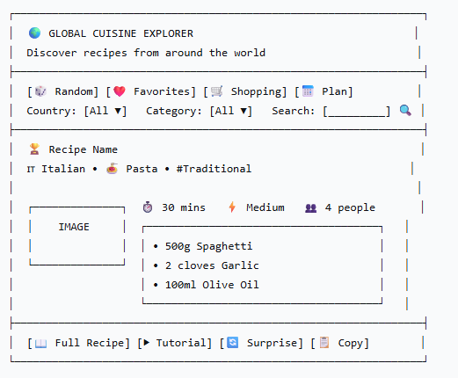

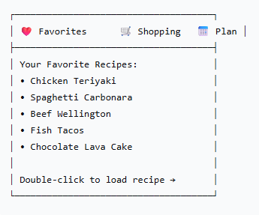

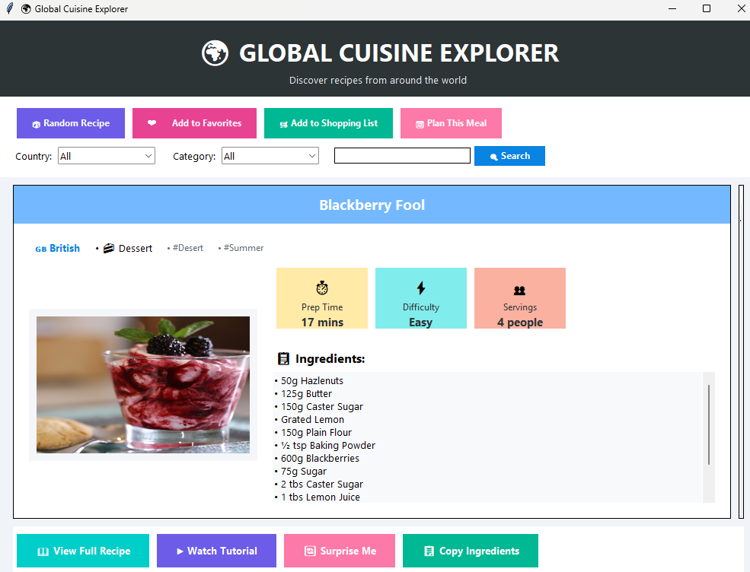

Technical Description & Walkthrough

Testing

The application follows an object-oriented design with a single main class CuisineExplorer that manages all functionality. Key technical implementations include:
1. API Integration Layer
python
def get_random_recipe(self):
try:
response = requests.get(f"{self.BASE_URL}/random.php")
if response.status_code == 200:
data = response.json()
if data.get("meals"):
self.current_recipe = data["meals"][0]
self.display_recipe()
except Exception as e:
messagebox.showerror("Connection Error", str(e))
Explanation: This method demonstrates robust API error handling with try-catch blocks and status code checking.
2. Dynamic GUI Updates
python
def display_recipe(self):
# Update title
self.recipe_title.config(text=self.current_recipe["strMeal"])

# Update country flag and category
country = self.current_recipe.get("strArea", "Unknown")
flag = self.countries.get(country, "🌐")

# Load image asynchronously
self.load_recipe_image()

# Update ingredients list
self.display_ingredients()
Explanation: The GUI updates dynamically based on API response without needing page reloads.
3. User Data Management
python
def add_to_favorites(self):
recipe_name = self.current_recipe["strMeal"]
if recipe_name not in self.favorites:
self.favorites.append(recipe_name)
self.favorites_listbox.insert(tk.END, recipe_name)
Explanation: User preferences are stored in-memory arrays with duplicate prevention.
4. Image Handling with PIL
python
def load_recipe_image(self):
image_url = self.current_recipe.get("strMealThumb")
if image_url:
response = requests.get(image_url)
img_data = response.content
img = Image.open(io.BytesIO(img_data))
img = img.resize((280, 180), Image.Resampling.LANCZOS)
photo = ImageTk.PhotoImage(img)
self.image_label.config(image=photo)
self.image_label.image = photo
Explanation: Images are downloaded from API URLs, resized for UI consistency, and cached properly.

TESTING
Evaluation | Observation | Evidence (Screenshot) | status
Add to Favorites | Recipes can be added and retrieved from favorites | 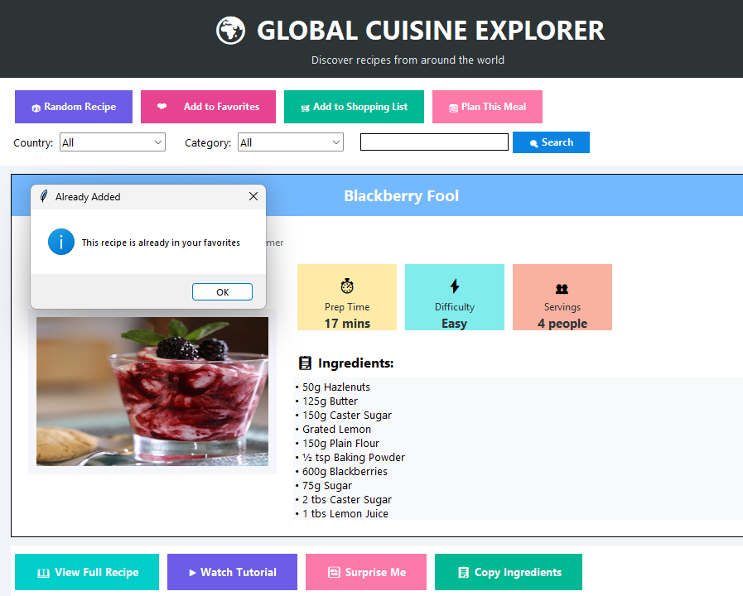 | pass
Shopping List | Ingredients are added to shopping list correctly | 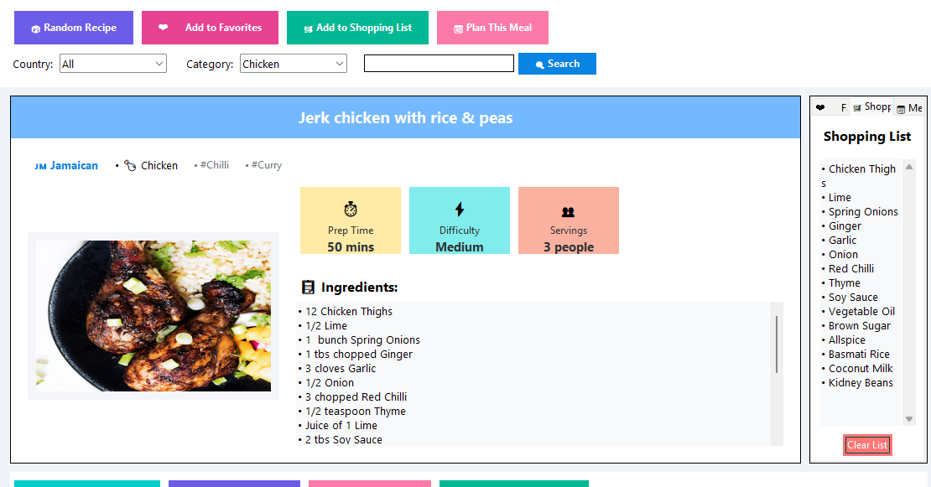 | pass
Random Recipe | Random recipe button fetches and displays new recipe | 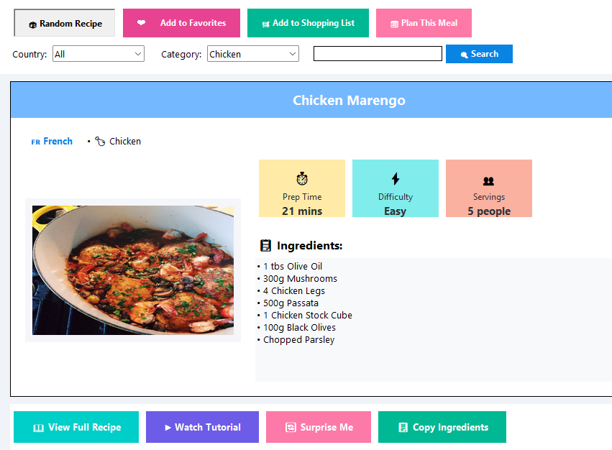 | pass
Meal Planning | Recipes can be assigned to days of the week | 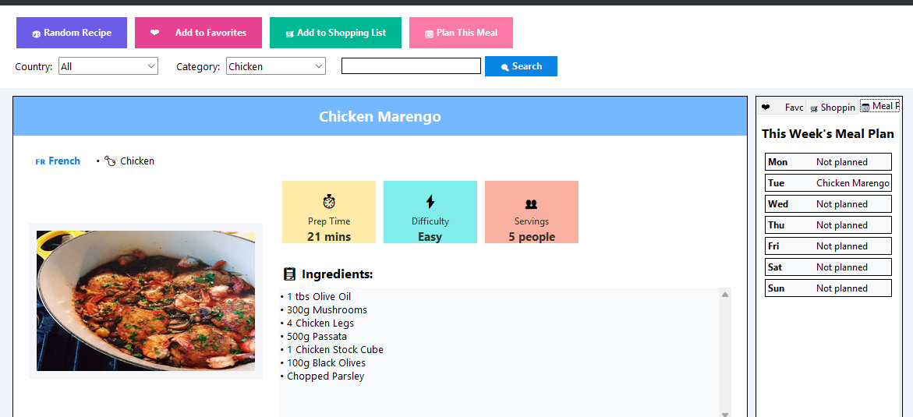 | pass

Critical Reflection
The interesting thing about the work is:
Global Cuisine Explorer manages to implement advanced API integration and multiple endpoints and performs extensive data processing successfully. The interface is also user friendly having an eye pleasing color scheme, user friendly layouts, and the use of emojis to enhance user experiences. The app does not just consume APIs but introduces a more practical use of it, such as meal planning and the creation of a shopping list that would make it useful in real life. The object-oriented architecture enables the code to be modular and maintainable and full error handling to allow robustness.

What could be improved:
Persistent Storage: at this point, user data (favorites, shopping lists) is absent in the physical file, and is only saved in memory and lost on application close. The usability would greatly be enhanced by using the local file storage or by database integration.

Performance Optimization: Image loading can be optimized with caching in order to lower the unnecessary download and speed-up the response.

Advanced Functionality: The addition of nutritional details, calories counter or dietary restriction filter (gluten free, vegan) would add value to the app.

Multi-language Support: Now, there are English-only recipes. The integration of translation features would make the application reach a greater number of people.

Export Functionality: A user is not able to export his or her shopping carts or meals plans to any other format ( PDF, text file, or calendar integration ).

The things that I should learn to achieve these improvements include:
Database Integration: familiarize oneself with SQLite or JSON file manipulation to store persistent data.

Advanced Tkinter: Learn more about more advanced widgets and threading in order to perform better.

Other APIs: Nutritional APIs Research APIs which may be used to supplement the recipe data.

Internationalization: Study about gettext or other multi-language localization systems.

Export Libraries: Python libraries to generate PDFs and date integration.

The process of development supported the significant role of proper API documentation review and user-focused design. The next version would come with user testing to determine the pain points and the features that the users want but are not offered at the present.

Appendix
import tkinter as tk
from tkinter import ttk, messagebox, scrolledtext
import requests
import json
from PIL import Image, ImageTk
import io
import webbrowser
from datetime import datetime
import random

class CuisineExplorer:
"""Main application with enhanced features"""

def __init__(self, root):
self.root = root
self.root.title("🌍 Global Cuisine Explorer")
self.root.geometry("1000x750")

# API base URL
self.BASE_URL = "https://www.themealdb.com/api/json/v1/1"

# Current data
self.current_recipe = None
self.current_country = "All"

# User data
self.favorites = []
self.shopping_list = []
self.meal_plan = {}

# Country data with emoji flags
self.countries = {
"All": "🌐",
"American": "🇺🇸", "British": "🇬🇧", "Canadian": "🇨🇦",
"Chinese": "🇨🇳", "Croatian": "🇭🇷", "Dutch": "🇳🇱",
"Egyptian": "🇪🇬", "French": "🇫🇷", "Greek": "🇬🇷",
"Indian": "🇮🇳", "Irish": "🇮🇪", "Italian": "🇮🇹",
"Jamaican": "🇯🇲", "Japanese": "🇯🇵", "Kenyan": "🇰🇪",
"Malaysian": "🇲🇾", "Mexican": "🇲🇽", "Moroccan": "🇲🇦",
"Polish": "🇵🇱", "Portuguese": "🇵🇹", "Russian": "🇷🇺",
"Spanish": "🇪🇸", "Thai": "🇹🇭", "Tunisian": "🇹🇳",
"Turkish": "🇹🇷", "Unknown": "❓", "Vietnamese": "🇻🇳"
}

# Dietary categories
self.categories = {
"All": "🍽️",
"Beef": "🥩", "Chicken": "🍗", "Dessert": "🍰",
"Lamb": "🐑", "Miscellaneous": "🌀", "Pasta": "🍝",
"Pork": "🐖", "Seafood": "🐟", "Vegetarian": "🥬",
"Breakfast": "☕", "Side": "🥗", "Starter": "🥢"
}

# Setup modern UI
self.setup_ui()

# Load initial random recipe
self.get_random_recipe()

def setup_ui(self):
"""Setup the beautiful user interface"""
# Main container with gradient background simulation
main_frame = tk.Frame(self.root, bg='#f0f4f8')
main_frame.pack(fill='both', expand=True)

# Header with gradient effect
header = tk.Frame(main_frame, bg='#2d3436', height=100)
header.pack(fill='x')
header.pack_propagate(False)

# Title with emoji
title_frame = tk.Frame(header, bg='#2d3436')
title_frame.pack(expand=True, fill='both')

tk.Label(
title_frame,
text="🌍 GLOBAL CUISINE EXPLORER",
font=("Segoe UI", 24, "bold"),
fg='white',
bg='#2d3436'
).pack(pady=(15, 0))

tk.Label(
title_frame,
text="Discover recipes from around the world",
font=("Segoe UI", 10),
fg='#dfe6e9',
bg='#2d3436'
).pack()

# Control Panel with modern design
control_frame = tk.Frame(main_frame, bg='#ffffff', padx=20, pady=15)
control_frame.pack(fill='x')

# Quick action buttons
quick_frame = tk.Frame(control_frame, bg='#ffffff')
quick_frame.pack(fill='x', pady=(0, 10))

buttons = [
("🎲 Random Recipe", self.get_random_recipe, '#6c5ce7'),
("❤️ Add to Favorites", self.add_to_favorites, '#e84393'),
("🛒 Add to Shopping List", self.add_to_shopping_list, '#00b894'),
("📅 Plan This Meal", self.add_to_meal_plan, '#fd79a8')
]

for text, command, color in buttons:
btn = tk.Button(
quick_frame,
text=text,
command=command,
bg=color,
fg='white',
font=("Segoe UI", 9, "bold"),
padx=15,
pady=8,
relief='flat',
cursor='hand2'
)
btn.pack(side='left', padx=5)

# Filter controls
filter_frame = tk.Frame(control_frame, bg='#ffffff')
filter_frame.pack(fill='x')

# Country filter
tk.Label(filter_frame, text="Country:", bg='#ffffff',
font=("Segoe UI", 10)).pack(side='left', padx=(0, 5))

self.country_var = tk.StringVar(value="All")
self.country_combo = ttk.Combobox(
filter_frame,
textvariable=self.country_var,
values=list(self.countries.keys()),
state="readonly",
width=15,
font=("Segoe UI", 10)
)
self.country_combo.pack(side='left', padx=(0, 20))
self.country_combo.bind("<<ComboboxSelected>>", self.filter_by_country)

# Category filter
tk.Label(filter_frame, text="Category:", bg='#ffffff',
font=("Segoe UI", 10)).pack(side='left', padx=(0, 5))

self.category_var = tk.StringVar(value="All")
self.category_combo = ttk.Combobox(
filter_frame,
textvariable=self.category_var,
values=list(self.categories.keys()),
state="readonly",
width=15,
font=("Segoe UI", 10)
)
self.category_combo.pack(side='left', padx=(0, 20))
self.category_combo.bind("<<ComboboxSelected>>", self.filter_by_category)

# Search
search_frame = tk.Frame(filter_frame, bg='#ffffff')
search_frame.pack(side='left')

self.search_var = tk.StringVar()
search_entry = tk.Entry(
search_frame,
textvariable=self.search_var,
width=25,
font=("Segoe UI", 10),
relief='solid',
bd=1
)
search_entry.pack(side='left', padx=(0, 5))

search_btn = tk.Button(
search_frame,
text="🔍 Search",
command=self.search_recipe,
bg='#0984e3',
fg='white',
font=("Segoe UI", 9, "bold"),
padx=15,
relief='flat'
)
search_btn.pack(side='left')

# Main content area
content_frame = tk.Frame(main_frame, bg='#f0f4f8')
content_frame.pack(fill='both', expand=True, padx=20, pady=10)

# Left column - Recipe display
left_frame = tk.Frame(content_frame, bg='white', relief='solid', bd=1)
left_frame.pack(side='left', fill='both', expand=True, padx=(0, 10))

# Recipe header
recipe_header = tk.Frame(left_frame, bg='#74b9ff', height=50)
recipe_header.pack(fill='x')
recipe_header.pack_propagate(False)

self.recipe_title = tk.Label(
recipe_header,
text="Select a Recipe",
font=("Segoe UI", 14, "bold"),
fg='white',
bg='#74b9ff'
)
self.recipe_title.pack(expand=True)

# Recipe content
recipe_content = tk.Frame(left_frame, bg='white')
recipe_content.pack(fill='both', expand=True, padx=20, pady=20)

# Recipe info (country, category, tags)
self.info_frame = tk.Frame(recipe_content, bg='white')
self.info_frame.pack(fill='x', pady=(0, 15))

# Image and details frame
details_frame = tk.Frame(recipe_content, bg='white')
details_frame.pack(fill='both', expand=True)

# Image
image_container = tk.Frame(details_frame, bg='#f5f6fa', width=300, height=200)
image_container.pack(side='left', padx=(0, 20))
image_container.pack_propagate(False)

self.image_label = tk.Label(image_container, bg='#f5f6fa')
self.image_label.pack(expand=True)

# Quick info
info_right = tk.Frame(details_frame, bg='white')
info_right.pack(side='left', fill='both', expand=True)

# Info cards
cards_frame = tk.Frame(info_right, bg='white')
cards_frame.pack(fill='x', pady=(0, 15))

# Create info cards
self.cards = {}
card_data = [
("Prep Time", "⏱️", "30 mins", '#ffeaa7'),
("Difficulty", "⚡", "Medium", '#81ecec'),
("Servings", "👥", "4 people", '#fab1a0')
]

for title, icon, default, color in card_data:
card = tk.Frame(cards_frame, bg=color, width=120, height=80)
card.pack(side='left', padx=5)
card.pack_propagate(False)

# Card content
tk.Label(card, text=icon, font=("Segoe UI", 14),
bg=color).pack(pady=(10, 0))
tk.Label(card, text=title, font=("Segoe UI", 9),
bg=color, fg='#2d3436').pack()
value_label = tk.Label(card, text=default, font=("Segoe UI", 11, "bold"),
bg=color, fg='#2d3436')
value_label.pack()
self.cards[title.lower().replace(" ", "_")] = value_label

# Ingredients
tk.Label(info_right, text="📋 Ingredients:", font=("Segoe UI", 12, "bold"),
bg='white', anchor='w').pack(anchor='w', pady=(10, 5))

self.ingredients_text = scrolledtext.ScrolledText(
info_right,
height=8,
font=("Segoe UI", 10),
bg='#f8f9fa',
relief='flat',
bd=1
)
self.ingredients_text.pack(fill='both', expand=True)

# Right column - Features
right_frame = tk.Frame(content_frame, bg='white', width=300, relief='solid', bd=1)
right_frame.pack(side='right', fill='y')
right_frame.pack_propagate(False)

# Features tabs
self.notebook = ttk.Notebook(right_frame)
self.notebook.pack(fill='both', expand=True)

# Favorites tab
favorites_tab = tk.Frame(self.notebook, bg='white')
self.notebook.add(favorites_tab, text='❤️ Favorites')
self.setup_favorites_tab(favorites_tab)

# Shopping List tab
shopping_tab = tk.Frame(self.notebook, bg='white')
self.notebook.add(shopping_tab, text='🛒 Shopping List')
self.setup_shopping_tab(shopping_tab)

# Meal Plan tab
mealplan_tab = tk.Frame(self.notebook, bg='white')
self.notebook.add(mealplan_tab, text='📅 Meal Plan')
self.setup_mealplan_tab(mealplan_tab)

# Action buttons at bottom
action_frame = tk.Frame(main_frame, bg='#ffffff', pady=10)
action_frame.pack(fill='x', padx=20)

action_buttons = [
("📖 View Full Recipe", self.show_full_recipe, '#00cec9'),
("▶ Watch Tutorial", self.open_video, '#6c5ce7'),
("🔄 Surprise Me", self.get_surprise_meal, '#fd79a8'),
("📋 Copy Ingredients", self.copy_ingredients, '#00b894')
]

for text, command, color in action_buttons:
btn = tk.Button(
action_frame,
text=text,
command=command,
bg=color,
fg='white',
font=("Segoe UI", 10, "bold"),
padx=20,
pady=8,
relief='flat'
)
btn.pack(side='left', padx=5)

# Status bar
self.status_bar = tk.Label(
main_frame,
text="Ready to explore global cuisines!",
bg='#2d3436',
fg='white',
anchor='w',
padx=15,
font=("Segoe UI", 9)
)
self.status_bar.pack(side='bottom', fill='x')

def setup_favorites_tab(self, parent):
"""Setup favorites tab"""
tk.Label(parent, text="Your Favorite Recipes",
font=("Segoe UI", 12, "bold"), bg='white').pack(pady=10)

self.favorites_listbox = tk.Listbox(
parent,
font=("Segoe UI", 10),
bg='#f8f9fa',
relief='flat',
height=15
)
self.favorites_listbox.pack(fill='both', expand=True, padx=10, pady=5)

# Bind double-click to load recipe
self.favorites_listbox.bind('<Double-Button-1>', self.load_favorite)

def setup_shopping_tab(self, parent):
"""Setup shopping list tab"""
tk.Label(parent, text="Shopping List",
font=("Segoe UI", 12, "bold"), bg='white').pack(pady=10)

self.shopping_text = scrolledtext.ScrolledText(
parent,
font=("Segoe UI", 10),
bg='#f8f9fa',
relief='flat',
height=15
)
self.shopping_text.pack(fill='both', expand=True, padx=10, pady=5)

# Add some default items
self.shopping_text.insert(tk.END, "• Olive oil\n• Salt\n• Black pepper\n• Garlic\n• Onions")
self.shopping_text.config(state='disabled')

# Clear button
tk.Button(parent, text="Clear List", command=self.clear_shopping_list,
bg='#ff7675', fg='white', relief='flat').pack(pady=5)

def setup_mealplan_tab(self, parent):
"""Setup meal plan tab"""
tk.Label(parent, text="This Week's Meal Plan",
font=("Segoe UI", 12, "bold"), bg='white').pack(pady=10)

days = ["Monday", "Tuesday", "Wednesday", "Thursday",
"Friday", "Saturday", "Sunday"]

self.mealplan_labels = {}
for day in days:
frame = tk.Frame(parent, bg='#f8f9fa', relief='solid', bd=1)
frame.pack(fill='x', padx=10, pady=2)

tk.Label(frame, text=day[:3], width=8, anchor='w',
bg='#f8f9fa', font=("Segoe UI", 9, "bold")).pack(side='left')

label = tk.Label(frame, text="Not planned", anchor='w',
bg='#f8f9fa', font=("Segoe UI", 9))
label.pack(side='left', fill='x', expand=True)
self.mealplan_labels[day] = label

def get_random_recipe(self):
"""Fetch a random recipe"""
self.set_status("Fetching a random recipe from around the world...")

try:
response = requests.get(f"{self.BASE_URL}/random.php")

if response.status_code == 200:
data = response.json()
if data.get("meals"):
self.current_recipe = data["meals"][0]
self.display_recipe()
self.set_status(f"Loaded {self.current_recipe['strMeal']} from {self.current_recipe.get('strArea', 'Unknown')}")
else:
messagebox.showerror("Error", "No recipe found")
except Exception as e:
messagebox.showerror("Connection Error", str(e))

def filter_by_country(self, event=None):
"""Filter recipes by country"""
country = self.country_var.get()
if country == "All":
self.get_random_recipe()
return

self.set_status(f"Finding {country} recipes...")

try:
response = requests.get(f"{self.BASE_URL}/filter.php?a={country}")

if response.status_code == 200:
data = response.json()
if data.get("meals"):
# Pick random recipe from this country
meal_id = random.choice(data["meals"])["idMeal"]
self.get_recipe_by_id(meal_id)
else:
messagebox.showinfo("No Recipes", f"No {country} recipes found")
except Exception as e:
messagebox.showerror("Error", str(e))

def filter_by_category(self, event=None):
"""Filter recipes by category"""
category = self.category_var.get()
if category == "All":
self.get_random_recipe()
return

self.set_status(f"Finding {category} recipes...")

try:
response = requests.get(f"{self.BASE_URL}/filter.php?c={category}")

if response.status_code == 200:
data = response.json()
if data.get("meals"):
meal_id = random.choice(data["meals"])["idMeal"]
self.get_recipe_by_id(meal_id)
else:
messagebox.showinfo("No Recipes", f"No {category} recipes found")
except Exception as e:
messagebox.showerror("Error", str(e))

def search_recipe(self):
"""Search recipe by name"""
search_term = self.search_var.get().strip()
if not search_term:
messagebox.showwarning("Warning", "Please enter a search term")
return

self.set_status(f"Searching for '{search_term}'...")

try:
response = requests.get(f"{self.BASE_URL}/search.php?s={search_term}")

if response.status_code == 200:
data = response.json()
if data.get("meals"):
self.current_recipe = data["meals"][0]
self.display_recipe()
self.set_status(f"Found '{search_term}'!")
else:
messagebox.showinfo("Not Found", f"No recipes found for '{search_term}'")
except Exception as e:
messagebox.showerror("Error", str(e))

def get_recipe_by_id(self, meal_id):
"""Fetch recipe by ID"""
try:
response = requests.get(f"{self.BASE_URL}/lookup.php?i={meal_id}")

if response.status_code == 200:
data = response.json()
if data.get("meals"):
self.current_recipe = data["meals"][0]
self.display_recipe()
except Exception as e:
messagebox.showerror("Error", str(e))

def display_recipe(self):
"""Display the current recipe"""
if not self.current_recipe:
return

# Update title
self.recipe_title.config(text=self.current_recipe["strMeal"])

# Update info frame
for widget in self.info_frame.winfo_children():
widget.destroy()

# Country flag and name
country = self.current_recipe.get("strArea", "Unknown")
flag = self.countries.get(country, "🌐")
tk.Label(self.info_frame, text=f"{flag} {country}",
bg='white', font=("Segoe UI", 10, "bold"),
fg='#0984e3').pack(side='left', padx=5)

# Category
category = self.current_recipe.get("strCategory", "Unknown")
cat_icon = self.categories.get(category, "🍽️")
tk.Label(self.info_frame, text=f" • {cat_icon} {category}",
bg='white', font=("Segoe UI", 10)).pack(side='left', padx=5)

# Tags if available
tags = self.current_recipe.get("strTags", "")
if tags:
for tag in tags.split(",")[:2]:
tk.Label(self.info_frame, text=f" • #{tag.strip()}",
bg='white', font=("Segoe UI", 9),
fg='#636e72').pack(side='left', padx=5)

# Update info cards with estimated values
self.cards["prep_time"].config(text=f"{random.randint(15, 60)} mins")
self.cards["difficulty"].config(text=random.choice(["Easy", "Medium", "Hard"]))
self.cards["servings"].config(text=f"{random.randint(2, 8)} people")

# Load image
self.load_recipe_image()

# Display ingredients
self.display_ingredients()

def load_recipe_image(self):
"""Load and display recipe image"""
image_url = self.current_recipe.get("strMealThumb")
if not image_url:
return

try:
response = requests.get(image_url)
img_data = response.content

img = Image.open(io.BytesIO(img_data))
img = img.resize((280, 180), Image.Resampling.LANCZOS)
photo = ImageTk.PhotoImage(img)

self.image_label.config(image=photo)
self.image_label.image = photo

except Exception as e:
print(f"Image error: {e}")

def display_ingredients(self):
"""Display recipe ingredients"""
self.ingredients_text.delete(1.0, tk.END)

ingredients = []
for i in range(1, 21):
ingredient = self.current_recipe.get(f"strIngredient{i}")
measure = self.current_recipe.get(f"strMeasure{i}")

if ingredient and ingredient.strip():
ingredients.append(f"• {measure.strip()} {ingredient.strip()}")

self.ingredients_text.insert(tk.END, "\n".join(ingredients))
self.ingredients_text.config(state='normal')

def add_to_favorites(self):
"""Add current recipe to favorites"""
if not self.current_recipe:
messagebox.showwarning("Warning", "No recipe selected")
return

recipe_name = self.current_recipe["strMeal"]
if recipe_name not in self.favorites:
self.favorites.append(recipe_name)
self.favorites_listbox.insert(tk.END, recipe_name)
self.set_status(f"Added '{recipe_name}' to favorites!")
else:
messagebox.showinfo("Already Added", "This recipe is already in your favorites")

def load_favorite(self, event):
"""Load a recipe from favorites"""
selection = self.favorites_listbox.curselection()
if selection:
recipe_name = self.favorites_listbox.get(selection[0])
self.search_var.set(recipe_name)
self.search_recipe()

def add_to_shopping_list(self):
"""Add recipe ingredients to shopping list"""
if not self.current_recipe:
return

self.shopping_text.config(state='normal')

for i in range(1, 21):
ingredient = self.current_recipe.get(f"strIngredient{i}")
if ingredient and ingredient.strip():
item = f"• {ingredient.strip()}\n"
if item not in self.shopping_text.get(1.0, tk.END):
self.shopping_text.insert(tk.END, item)

self.shopping_text.config(state='disabled')
self.set_status("Ingredients added to shopping list!")

def clear_shopping_list(self):
"""Clear the shopping list"""
self.shopping_text.config(state='normal')
self.shopping_text.delete(1.0, tk.END)
self.shopping_text.config(state='disabled')
self.set_status("Shopping list cleared")

def add_to_meal_plan(self):
"""Add recipe to meal plan"""
if not self.current_recipe:
return

# Simple dialog to select day
dialog = tk.Toplevel(self.root)
dialog.title("Plan This Meal")
dialog.geometry("300x200")
dialog.configure(bg='white')

tk.Label(dialog, text="Select day for this meal:",
font=("Segoe UI", 12), bg='white').pack(pady=20)

day_var = tk.StringVar()
days = ["Monday", "Tuesday", "Wednesday", "Thursday",
"Friday", "Saturday", "Sunday"]

day_combo = ttk.Combobox(dialog, textvariable=day_var,
values=days, state="readonly")
day_combo.pack(pady=10)
day_combo.set(days[0])

def save_meal_plan():
day = day_var.get()
meal = self.current_recipe["strMeal"]
self.mealplan_labels[day].config(text=meal)
self.meal_plan[day] = meal
dialog.destroy()
self.set_status(f"Planned '{meal}' for {day}")

tk.Button(dialog, text="Save", command=save_meal_plan,
bg='#00b894', fg='white', padx=20).pack(pady=20)

def show_full_recipe(self):
"""Show full recipe details"""
if not self.current_recipe:
return

dialog = tk.Toplevel(self.root)
dialog.title(f"{self.current_recipe['strMeal']} - Full Recipe")
dialog.geometry("600x500")
dialog.configure(bg='white')

# Title
tk.Label(dialog, text=self.current_recipe["strMeal"],
font=("Segoe UI", 18, "bold"), bg='white').pack(pady=10)

# Instructions
tk.Label(dialog, text="Instructions:", font=("Segoe UI", 12, "bold"),
bg='white').pack(anchor='w', padx=20, pady=(10, 5))

instructions_text = scrolledtext.ScrolledText(
dialog,
font=("Segoe UI", 10),
bg='#f8f9fa',
relief='flat'
)
instructions_text.pack(fill='both', expand=True, padx=20, pady=(0, 20))

instructions = self.current_recipe.get("strInstructions", "")
instructions_text.insert(tk.END, instructions)
instructions_text.config(state='disabled')

def open_video(self):
"""Open YouTube tutorial"""
youtube_url = self.current_recipe.get("strYoutube")
if youtube_url:
webbrowser.open(youtube_url)
else:
messagebox.showinfo("No Video", "No tutorial video available for this recipe")

def get_surprise_meal(self):
"""Get a surprise meal based on random filters"""
# Random country or category
if random.choice([True, False]):
random_country = random.choice(list(self.countries.keys())[1:]) # Skip "All"
self.country_var.set(random_country)
self.filter_by_country()
else:
random_category = random.choice(list(self.categories.keys())[1:])
self.category_var.set(random_category)
self.filter_by_category()

def copy_ingredients(self):
"""Copy ingredients to clipboard"""
if self.current_recipe:
ingredients = []
for i in range(1, 21):
ingredient = self.current_recipe.get(f"strIngredient{i}")
measure = self.current_recipe.get(f"strMeasure{i}")
if ingredient and ingredient.strip():
ingredients.append(f"{measure.strip()} {ingredient.strip()}")

self.root.clipboard_clear()
self.root.clipboard_append("\n".join(ingredients))
self.set_status("Ingredients copied to clipboard!")

def set_status(self, message):
"""Update status bar"""
self.status_bar.config(text=message)

def main():
root = tk.Tk()
app = CuisineExplorer(root)
root.mainloop()

if __name__ == "__main__":
main()

Repository Screenshot
